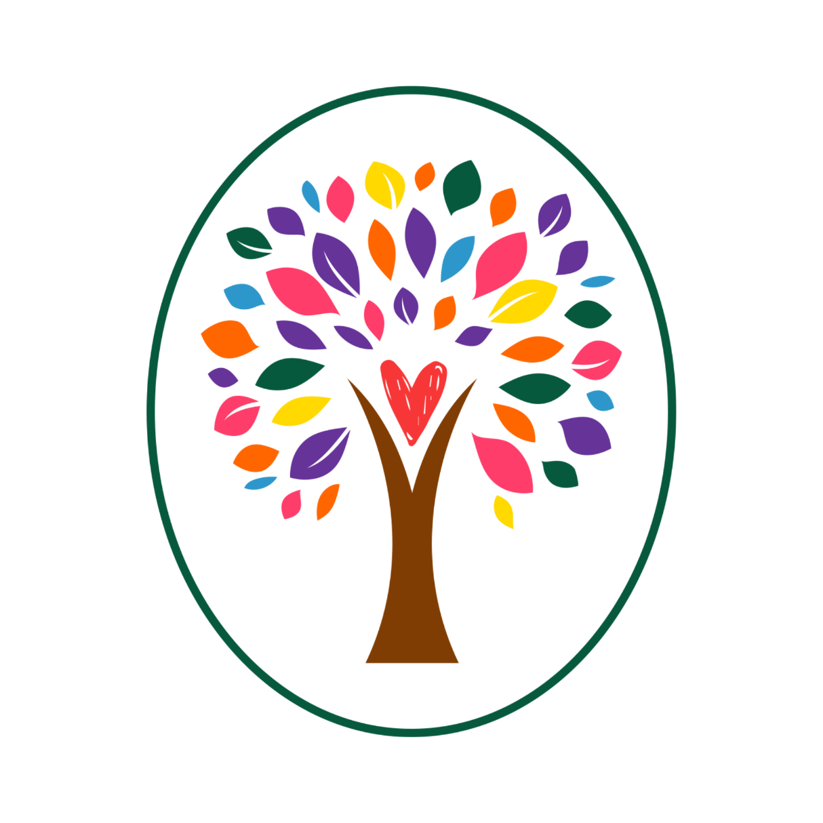
Garden of Neuro Publishing

Call for Submissions

The Garden of Neuro Institute is an incubator for women's agency and leadership. We are a community for women who want to see deeply and be seen for who we are. We are a diverse group of amazing women, with much to share.

As a women’s group, we offer opportunities for all genders and races.

Theme: Black Poetic Voices Will Not Be Silenced


This collection of videos will become a part of longer videos to be released on Black Poetry Day, October 17th, 2024.

Submissions will be accepted until September 15, 2024
Please use this form to submit your work

SEEKING SUBMISSIONS OF:
VIDEOS

- Begin with a Poem from a published Black Poet.
  - Please express the source of your poem.
- Where you can find online poems:
  - poets.org | Academy of American Poets
  - Poets | The Poetry Foundation
  - 10 of the Best Poems by African-American Poets – Interesting Literature

- Create an After Poem based on your chosen poem.
- Record both as a video of you reading each poem.
- Submit the video and
  - A third person, short bio is required.
  - Please keep this to 50 words or less. If it is longer, we have the discretion to shorten your bio.
  - A short bio of the Black Author you chose to honor and a link to their work if available. Include why you were inspired by the poem you chose. Combine both your bio and your author’s bio in the same document.

- Please use up to PG-related language.
- Videos must be at most 20 minutes in total to read both poems.
- Videos must be in .mp4 format.

Decisions will be provided by September 30, 2022
Publication Date: October 17, 2024

Enter Submission using this Google Doc form

Authors will be required to sign a contract before final acceptance.

We have zero tolerance for hate speech and will reject any work that reflects this.

We do not accept previously published works, including those shared on Social Media.

We do not accept simultaneous submissions.

Resources to Record Videos

Using your computer Using Zoom https://zoom.us/signin

Free Online Screen Recorder:

Free Online Screen Recorder ⏺ Capture & Record Videos (online-video-cutter.com)

Using your phone- PLEASE NOTE: these are offered as suggestions with no success reports.

Android https://youtu.be/cDF-2S21Huw?si=7yQ8_pE_Y7jHCv24
iPhone https://youtu.be/TKzpjQ7pDcA?si=CBB4F58JOA27cHZt

